Assignment-3.2
NAME: N.Chandana Priya
ROLL NO: 2303A52342
COURSE: AI Assisted Coding

Task Description-1
• Progressive Prompting for Calculator Design: Ask the AI to design a simple calculator program
by initially providing only the function name. Gradually enhance the prompt by adding comments
and usage examples.

Expected Output-1
• Comparison showing improvement in AI-generated calculator logic and structure.
PROMPT
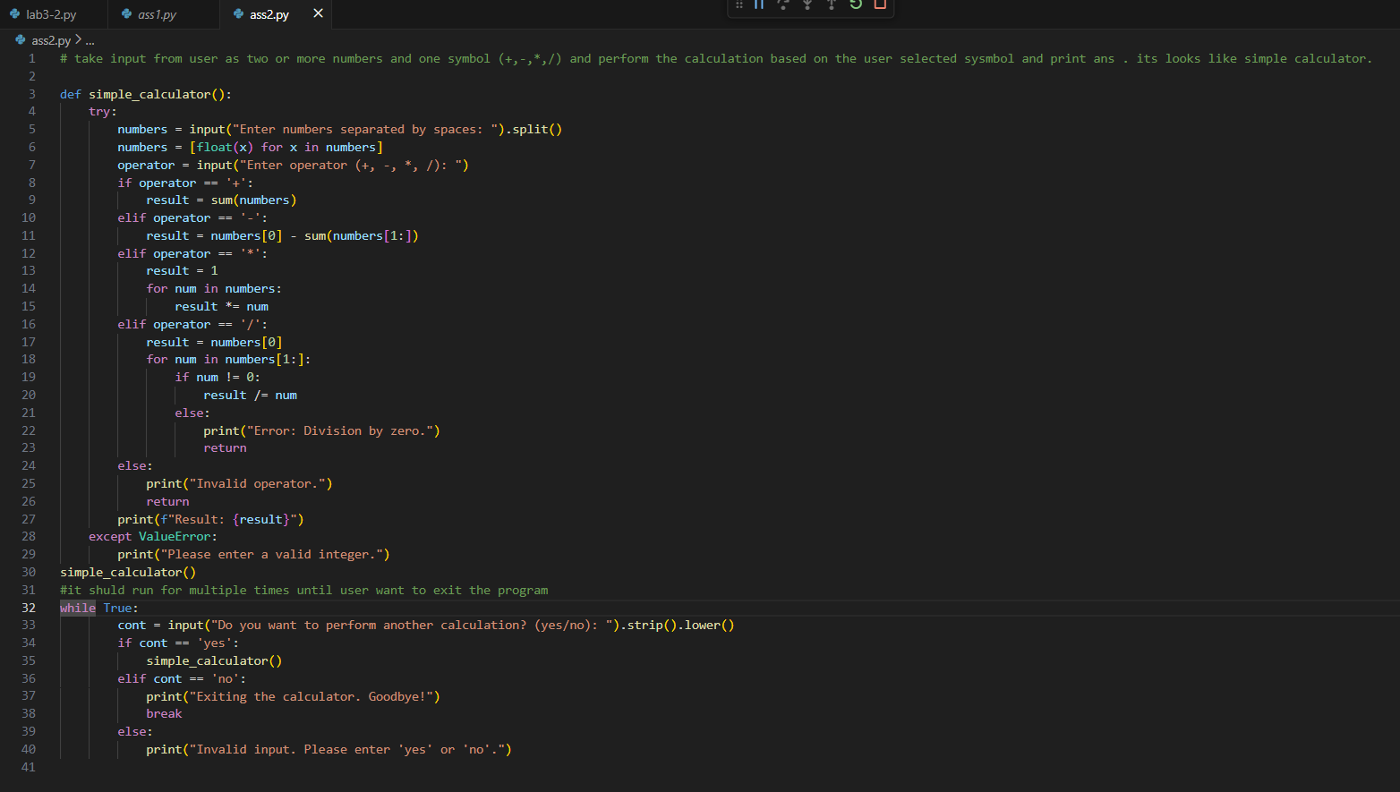
OUTPUT
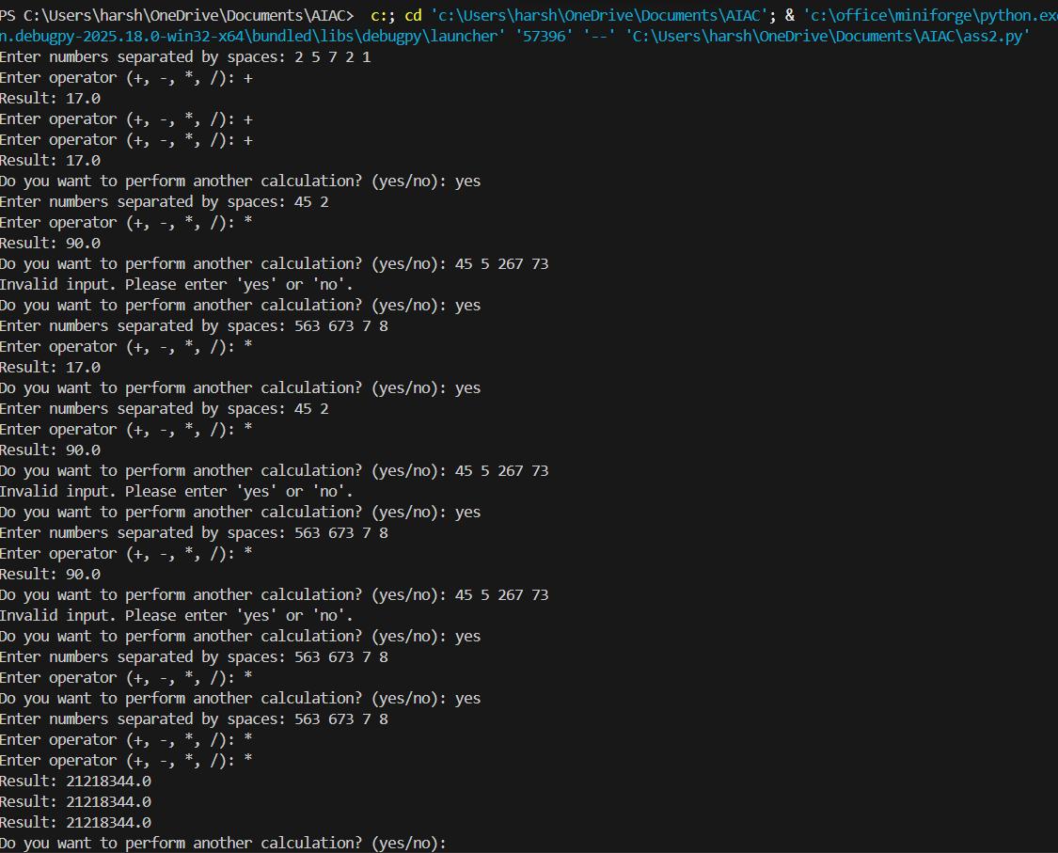
ANALYSIS
- The logic is better and basic operations are added.
- Still no error handling or input checking.
- It handles wrong inputs and division by zero.

Task Description-2
• Refining Prompts for Sorting Logic: Start with a vague prompt for sorting student marks, then refine it to clearly specify sorting order and constraints.
Expected Output-2
• AI-generated sorting function evolves from ambiguous logic to an accurate and efficient implementation.

PROMPT
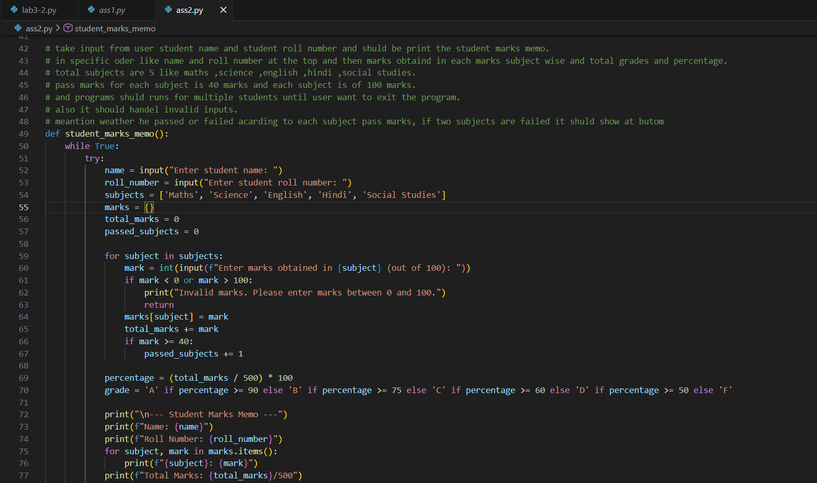
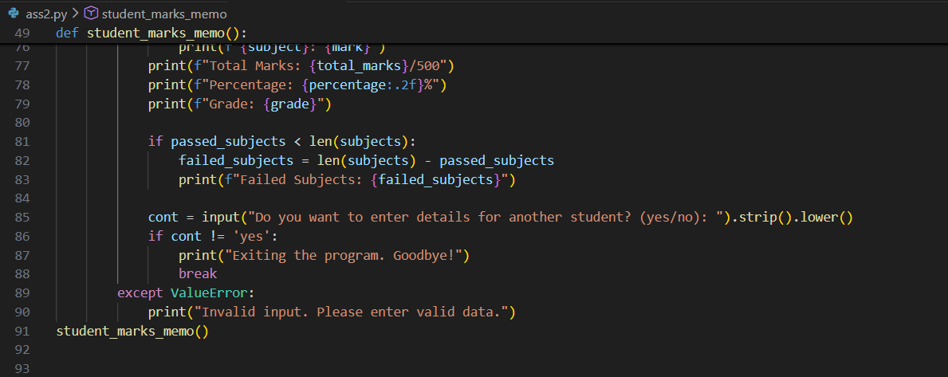
OUTPUT
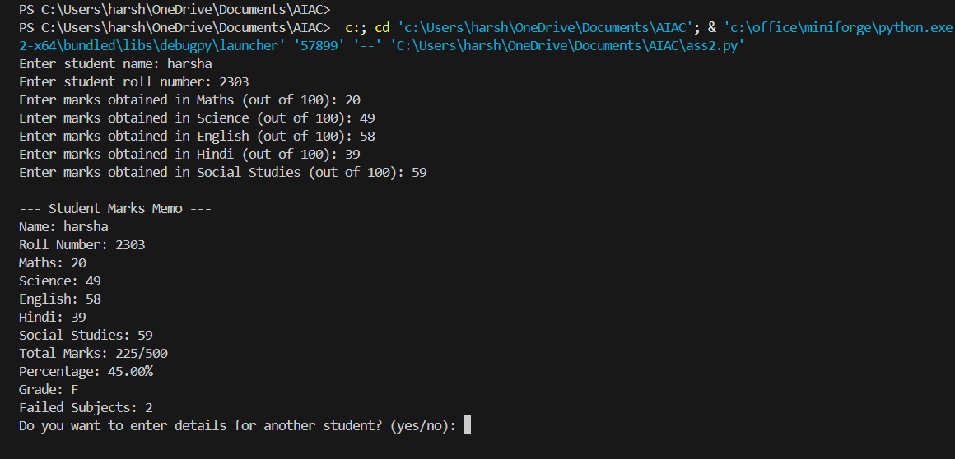
ANALAYSI
- The first prompt was unclear, so the AI gave a basic sorting program.
- After refining the prompt, the sorting order became clear.
- Adding constraints helped the AI handle only valid student marks.
- Refined prompts result in accurate and reliable code.

Task Description-3
• Few-Shot Prompting for Prime Number Validation: Provide multiple input-output examples for a function that checks whether a number is prime. Observe how few-shot prompting improves correctness.
Expected Output-3
• Improved prime-checking function with better edge-case handling
PROMPT
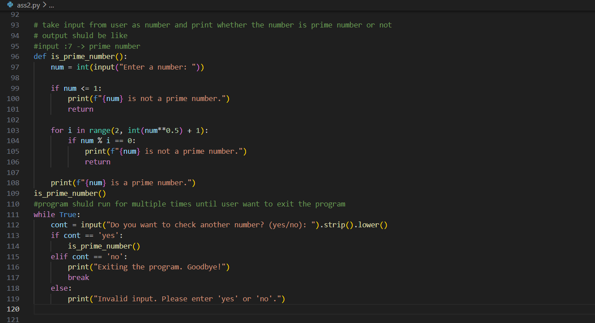
OUTPUT
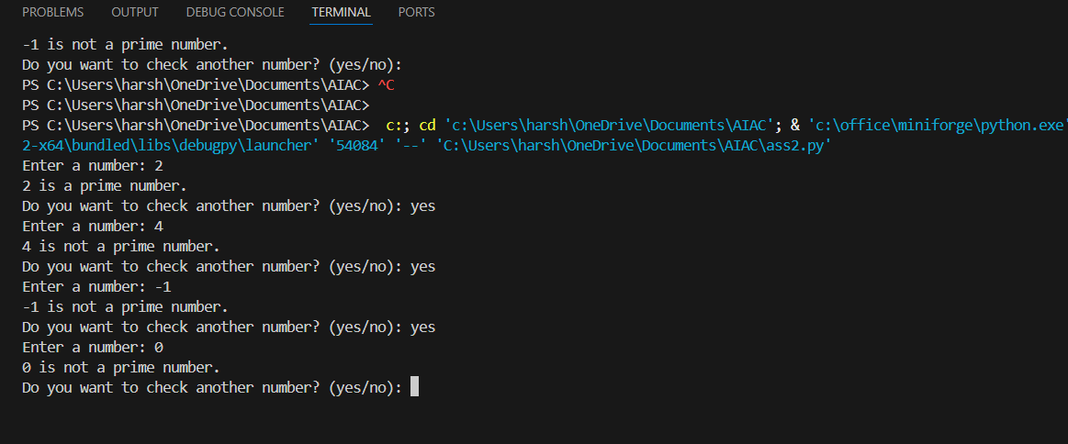
ANALYSIS
- The examples helped the AI understand prime and non-prime cases.
- The program now handles edge cases like 1 and negative numbers.
- Few-shot prompting improved correctness compared to zero-shot.
- The logic is efficient and reliable.

Task Description-4
• Prompt-Guided UI Design for Student Grading System: Create a user interface for a student grading system that calculates total marks, percentage, and grade based on user input.
Expected Output-4
• Well-structured UI code with accurate calculations and clear output display.
PROMPT
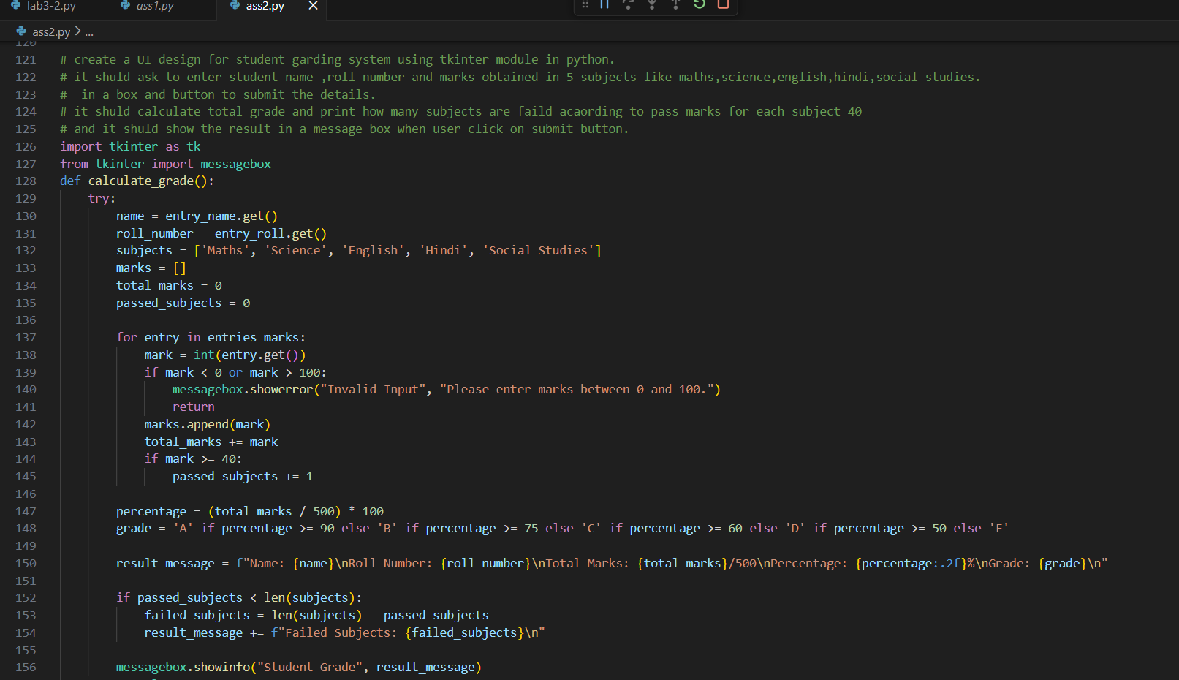
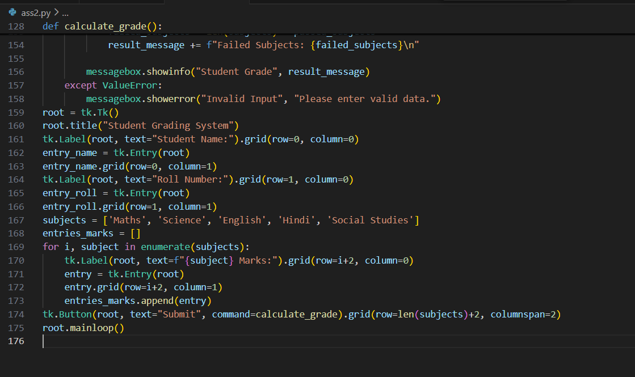
OUTPUT
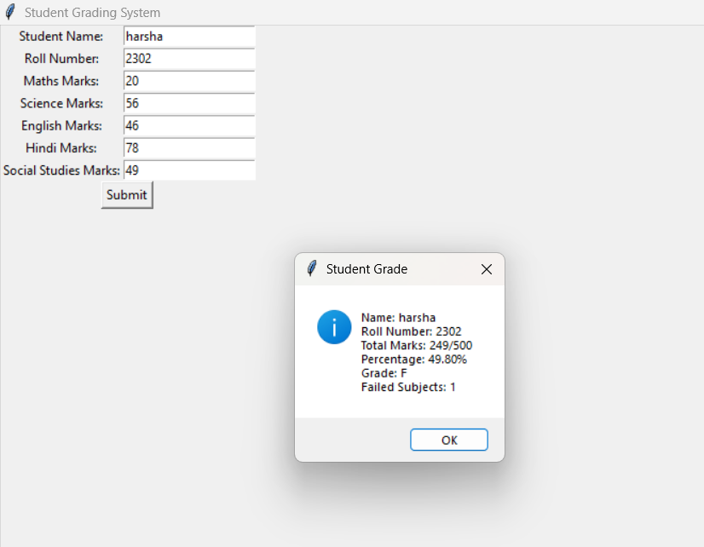

ANALYSIS
- The prompt clearly guides the AI to design a user interface for a student grading system.
- The UI allows users to enter marks and view total, percentage, and grade easily.
- Clear instructions help the AI generate accurate calculations and structured output.
- Prompt-guided UI design improves usability and correctness of the system.

Task Description-5
• Analyzing Prompt Specificity in Unit Conversion Functions: Improving a Unit Conversion Function (Kilometers to Miles and Miles to Kilometers) Using Clear Instructions.
Expected Output-5
• Analysis of code quality and accuracy differences across multiple prompt variations.
PROMPT
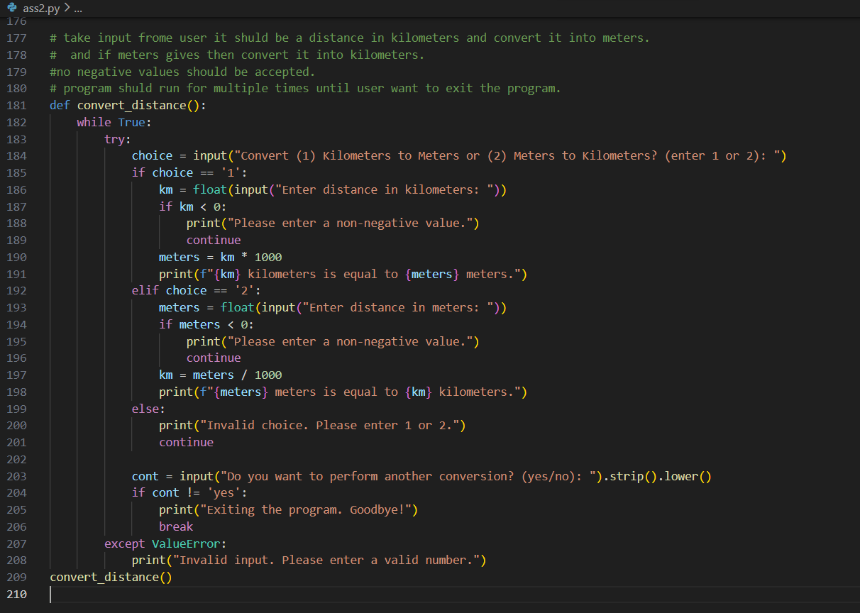
OUTPUT
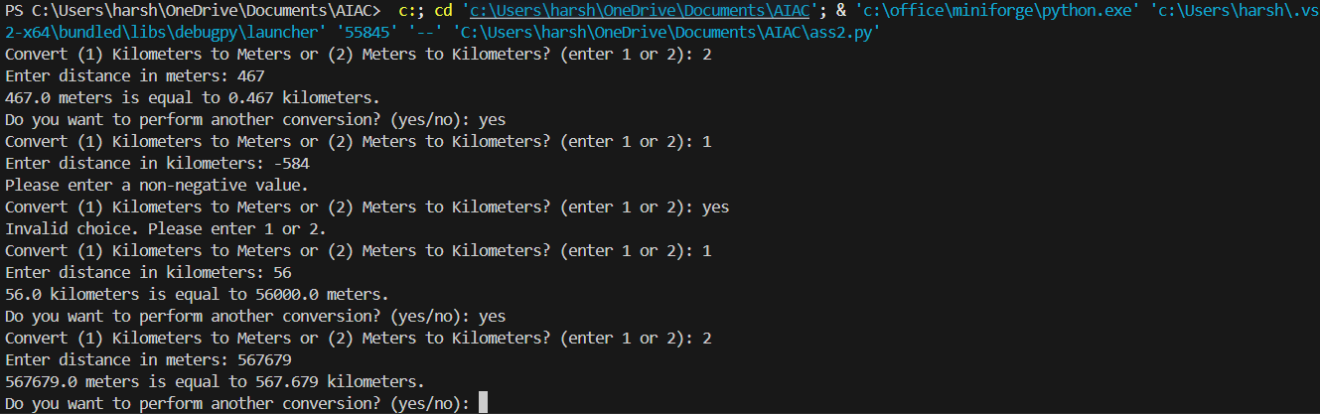
ANALYSI
- Clear and specific prompts help the AI generate accurate unit conversion functions.
- When the prompt is vague, the code may miss correct formulas or input validation.
- Adding clear instructions improves code quality, accuracy, and readability.
- Prompt specificity ensures correct conversion between kilometres and miles.

